***Chemistry***

**1: Essential Ideas**

**1.5: Measurement Uncertainty, Accuracy, and Precision**

45. Express each of the following numbers in exponential notation with correct significant figures:

(a) 704

(b) 0.03344

(c) 547.9

(d) 22086

(e) 1000.00

(f) 0.0000000651

(g) 0.007157

Solution

(a) 7.04 × 102; (b) 3.344 × 10–2; (c) 5.479 × 102; (d) 2.2086 × 104; (e) 1.00000 × 103; (f) 6.51 × 10–8; (g) 7.157 × 10–3

47. Indicate whether each of the following can be determined exactly or must be measured with some degree of uncertainty:

(a) the number of seconds in an hour

(b) the number of pages in this book

(c) the number of grams in your weight

(d) the number of grams in 3 kilograms

(e) the volume of water you drink in one day

(f) the distance from San Francisco to Kansas City

Solution

(a) exact; (b) exact; (c) uncertain; (d) exact; (e) uncertain; (f) uncertain

49. How many significant figures are contained in each of the following measurements?

(a) 53 cm

(b) 2.05 × 108 m

(c) 86,002 J

(d) 9.740 × 104 m/s

(e) 10.0613 m3

(f) 0.17 g/mL

(g) 0.88400 s

Solution

(a) two; (b) three; (c) five; (d) four; (e) six; (f) two; (g) five

51. Round off each of the following numbers to two significant figures:

(a) 0.436

(b) 9.000

(c) 27.2

(d) 135

(e) 1.497 × 10–3

(f) 0.445

Solution

(a) 0.44; (b) 9.0; (c) 27; (d) 140; (e) 1.5 × 10-3; (f) 0.44

53. Perform the following calculations and report each answer with the correct number of significant figures.

(a) 628 × 342

(b) (5.63 × 102) × (7.4 × 103)

(c) 

(d) 8119 × 0.000023

(e) 14.98 + 27,340 + 84.7593

(f) 42.7 + 0.259

Solution

(a) 2.15 × 105; (b) 4.2 × 106; (c) 2.08; (d) 0.19; (e) 27,440; (f) 43.0

55. Consider the results of the archery contest shown in this figure.

(a) Which archer is most precise?

(b) Which archer is most accurate?

(c) Who is both least precise and least accurate?

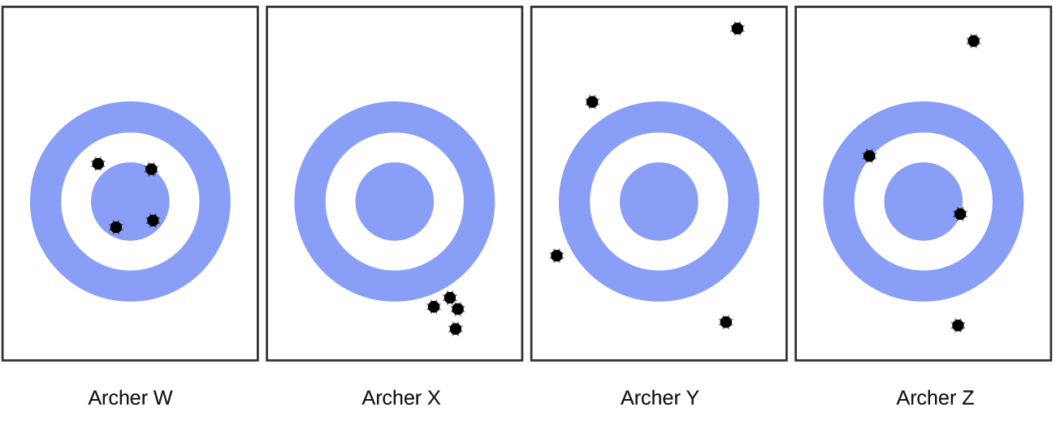

Solution

(a) Archer X; (b) Archer W; (c) Archer Y

This resource file is copyright 2015, Rice University. All Rights Reserved.